PRACTICAL KNOWLEDGE APPLICATION

A testing committee of three honorable full card members will be assembled by the Local to score the practical knowledge portion of the exam. Please read carefully the judging criteria for each section. An applicant will fail immediately if he/she exhibits unsafe work habits or damages any equipment. The testing committee will confer and subjectively decide if the applicant has satisfactorily completed the objectives and passed a particular section. Individual sections may be retaken once at the discretion of the testing committee; a second failure, however, requires the applicant to retake the failed portions of the exam no sooner than three months after the original testing date.

ELECTRICS

--Applicant must hang and circuit a light plot (a sample is shown below).

--Applicant should:
-tighten all C-clamps
-pull the shutters on all ellipsoidals
-focus fresnels to full flood
-space instruments properly
-fly batten to 15'-0"

1"=1'-0"
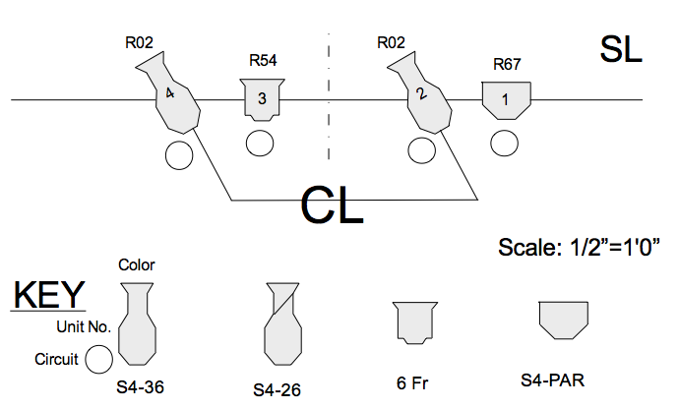

KNOTS

--Applicant must be able to tie:
two half-hitches,
square knot,
bowline,
sheet bend,
clove hitch,
figure eight, and
half-hitch over a belaying pin (belay knot).

--Applicant should be able to name an application for each of the above knots.

--Applicant must be able to tie a snub knot.

--Applicant should be able to tie a prussic knot.

--Applicant should be able to show the proper method of attaching a crosby to
a cable loop ("Never saddle a dead horse")

SOUND

Given appropriate adaptors and a pre-patched interface with a house sound system:

--Applicant must show sufficient understanding of sound to connect:
- a Crown PCC 160 (or equivalent) condenser mic
- a dynamic mic
- a tape deck or CD in mono
- to a mixing console and mix down the above inputs to the console's sum or mono pot.

--Applicant should power up the system correctly and must obtain sound at the house cluster when an input is applied to any of the three sources above.

--Applicant should show the location of the house equalizer and describe its function.

RIGGING

--During the hanging of the light plot in the electrics portion of this practical exam, applicant must operate the counterweight system safely and make proper calls when moving line sets.

--Applicant should:
- Describe the correct sequence in loading and unloading goods and counterweights.
- Exercise proper speed and control at all times.
- Weight previously hung electric properly.

--Applicant must:
Given appropriate selection of hardware:
- Assemble a "Five-Five Bridle with Five Baskets and a Ten Stinger".
- Properly tie a rigging rope to one side of the bridle with a 1 ft. Bowline.
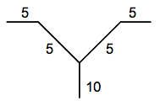

FOLLOW SPOT OPERATION

Test will consist of setting up a spotlight and taking called cues over headset, as in a show environment. Testing committee shall arrange three adjacent person-sized "targets" on stage (e.g. three mic stands with milk jugs or hats for heads), and supply candidate with 4 colors in frames.

Candidate shall be given time to install color, adjust the followspot, align a sight, set reference points, try out a few practice pickups, etc. When ready, examiner will call a series of cues (preferably on headset) in the manner of a stage manager, using "Warnings", "Standbys", and "Goes".

Candidate must successfully perform the cue sequence to the minimum satisfaction of the testing committee.

Applicant must be able to correctly identify color frames 1 and 6.

When ready, examiner will call a series of cues (preferably on headset) in the manner of a stage manager, using "Warnings", "Standbys", and "Goes".

Candidate must successfully perform the cue sequence to the minimum satisfaction of the testing committee.

Cues will include: bump and fade pickups and blackouts in various body sizes form full body to pin-spot, blind pickups, changes in size, changes of color in presets and live (bumps and rolls), “ballyhoo's”, back outs and restores with double “Goes”, etc

Sample cues:
- Pick Up center performer, full body, no color, in a Bump.
- ADD frame #___ in 3 count.
- with light cue ___, Iris to a Waist on center performer in a 5 count.
- with light cue___, Roll color to frame #___ in a 3 count.
- Blackout and Restore on a double Go ("GO pause GO").
- Open to 3/4 body and strip to cover all three perormers.
- Pull to Half-Body on SR Performer in a 5 count.
- Fade to 1/2 intensity in 3 count, hold; Fade to Black in a 5 count.
- Pick up center performer in a face pin spot, no color, in 4 counts.
- Open to full-body and balleyhoo the stage.
- Blackout!

RUNNING A FLAT

--With a flat or book flat at least 3'-0" wide and 10'-0" high, applicant should:
Move flat from horizontal to vertical orientation.
Safely run flat across the deck, checking for overhead obstructions.
Return flat to horizontal position.

WARDROBE
Test for Wardrobe Apprentices only

1. Applicant should arrive for the exam as you would for a work call.

2. Applicant must sew on following onto designated fabric:
- Three types of buttons (two-hole, four-hole, shank).
- Snap
- Hook and eye

3. Applicant must demonstrate the ability to make emergency seam repair.

4. Applicant must give a brief discussion of the proper actions and demonstrate the ability to make a repair in the following situation:

A zipper has just broken beyond repair, the actor has two minutes to entrance.

5. Applicant must assist an 'actor' in making a quick costume change.

6. Applicant must be able to iron six unidentifed fabrics in proper order and explain the order used (and any other precautions) when ironing the fabrics.

7. The Applicant must show ability to operate a domestic sewing machine.

8. Applicant must show the ability to fill and operate a clothes steamer. Applicant must show proper safety precautions, explain method(s) used to steam the garment, and how to avoid damage to fablic.

9. Applicant must polish a pair of dress shoes with paste polish.

10. Applicant must demonstrate different hand sewing stitches, such as cross-stitch, couch stitch (a.k.a. vertical hem), whipstitch, blind hem stitch.

11. You will be given a very wrinkled dress shirt and allowed 8 minutes to iron it.

12. Tie a man's tie (either on yourself or on another person) in a basic half-windsor.

Applicant must discuss the following:

13. You need to use a product that requires ventilation. You do not have any prearranged area for this. What precautions/place do you use?

Other than ventilation, what precautions do you use when applying and "curing" Barge Cement?

Materials for Practicals:

Stagehand:

Electrics:
2 Fresnels Ass't cable
2 Lekos Color frames for above
1 2-fer Ass't color cuts

Rope for knots
Snub rope (approx. 8 ft. of 1/2")

Short length of wire rope
Crosby clips to fit rope
Thimble to fit rope
"Rigging" rope
4- Five ft. Steel ropes
1- Ten ft. Steel rope
5 Shackles
Burlap bag

Sound:
Crown PCC or eqiv. (condensor) Phantom power supply
Dynamic mic Tape deck
Mixing console House equalizer
House amp and sound cluster
Ass't patch and interconnect cords for all of above

Counterweight system
Belaying pin or tie-off cleat

Running flat: min. 3 ft. x 10 ft.

Spotlight and three targets

